Study of coagulation properties of Holstein cow’s milk depending on the level of milk urea nitrogen in Macedonia dairy farms
Vesna Karapetkovska Hristova^{1*}, M. Ayaz Ahmad², Julijana Tomovska³ and Biljana Bogdanova Popov ⁴
^{1*}Faculty of Biotechnical Sciences, University of St. Kliment Ohridski, Partizanska, bb. 7000 Bitola, Macedonia
²Physics Department, College of Science, P.O. Box 741, University of Tabuk - 71491, Saudi Arabia.
³Faculty of Biotechnical Sciences, University of St. Kliment Ohridski, Partizanska, bb. 7000
Bitola, Macedonia
⁴Veterinary Faculty, P. O. Box 7000, Bitola, R. Macedonia
Corresponding Author’s e-mail: v.primavera79@gmail.com

Abstract: In this paper an attempt has been made to obtain some investigations for coagulation properties of milk produced by Holstein-Friesian cows reared on local Pelagonia’s farms in the R. Macedonia. Based on an initial screening in a herd of 60 Holstein-Friesians, the twenty five individual Holstein-Friesian cows were selected for good and poor chymosin - induced coagulation properties. These 25 selected cows were followed and re-sampled on several occasions to evaluate possible changes in coagulation properties according to the milk urea nitrogen level. We formed two groups of cow’s milk amongst 25 cows, group with normal milk urea nitrogen level, (10 cows) and with high milk urea nitrogen level (15 cows). In the follow-up study, the milk samples were analyzed for average values of DMY, MUN- milk urea nitrogen, (mol/L), lactose, protein and fat content (%), SNF- solids non fat (%) somatic cell count, pH, titratable acidity (Soxhlet-Henkel acidity, ⁰SH), as well as the rennet coagulation properties. The study describes the action of rennet on Holstein -Friesian breed cow’s milk with normal and high milk urea nitrogen level, as well as the effect of pH, temperature, and added calcium chloride on the coagulum development. Finally, the present investigations were undertaken to obtain a better insight into the problem of rennet coagulation of Holstein-Friesian cow’s milk, based on the level of milk urea nitrogen content.
Keywords:- Holstein- Friesian breed, DMY, Milk Urea Nitrogen (MUN) level, rennet coagulation properties.

Introduction
Within the worldwide level, as the dairy industry starts to grow and cheese manufacturing begins to be done in larger production facilities, it became apparent that a more scientific and standardized method for improving of milk coagulation properties should be developed. The
dairy industries are more and more interested in improving of milk coagulation properties (MCP), as a basic requirement of milk for cheese production (Summer et al., 2002) [1], as well as their affection of the cheese-making process efficiency (Aleandri et al., 1989; De Marchi et al., 2008; Wedholm et al., 2006) [2-4], and cheese yield and quality (O’Callaghan et al., 2000) [5]. The efficient manufacture of high-quality cheese consistently is a highly complex biotechnological process involving controlled destabilization and gelation of the milk protein, fermentation of the milk sugar lactose to lactic acid, dehydration of the gel to obtain cheese curd, and maturation of the curd to a ripened cheese with the desired quality attributes (sensory, aesthetic, usage, safety, convenience, wholesomeness, value for money) required by the consumers (O’Callaghan & Guinee, 2004) [6]. Therefore, the milk coagulation properties (MCP) might become very much beneficial at high levels, but there is a lack of support that it can be used in milk payment schemes as the accuracy of prediction models is not large enough for this purpose (De Marchi et al., 2009) [7]. Moreover, the prediction models have been developed using only samples that coagulate within 30 minutes from rennet addition.
The concentration and type of protein have a major influence on the micro-structure of acid- and rennet-coagulated milk gels, which markedly affects its rheological and syneretic properties, the recovery of fat and protein from milk to cheese and the yield of cheese (Schafer & Olson, 1975 [8]; Harwalkar & Kalab, 1980, 1981 [9, 10]; McMahon et al., 1993 [11]; Guinee et al., 1993 [12]). Besides these characteristics, genetic aspects play an important role in determining MCP. The present study about milk production potential is very limited. However, milk production varying between 1,800 and 12,775 kg during a lactation period between 9 and 18 months has been reported [1, 5 and references therein].
Numerous studies have demonstrated that high concentrations of MUN have negative effects on cheese making processes. In particular, high concentrations of urea are the direct or indirect cause of numerous problems, such as an increase in coagulation time, the formation of a more fragile and less structured curd, premature development of irregular fermentations, and a more intense proteolysis. With the analysis of MUN, it is possible to avoid possible problems in the cheese making processes. [13-14].
The present investigations were undertaken to obtain a better insight into the problem of rennet coagulation of Holstein-Friesian breed cow’s milk from Macedonia dairy farms. The study describes the action of rennet on cow’s milk with different milk urea level, as well as the effect of pH and temperature on the coagulum development.
Materials and Methodology Used
A. Milk Samples collection and laboratory analyses
Holstein-Friesian breed milk samples were taken at one dairy farm in the Bitola district in the Republic of Macedonia which is situated at an altitude of 1,233 metres above the Adriatic sea level. The dairy cows on the farm were fed ad libitum throughout the year as a total mixed ration, supplemented with concentrate according to standard practice and the cows were never turned out to graze. Rations before and after calving were formulated to exceed National Research Council recommendations (NRC,2001) [15], and the residues of the dietary feed were generally observed in the herd. All cows received the same lactation diet for ad libitum intake throughout the experimental period post calving. The milk samples were collected from the morning milking of the dairy cows (6.00 - 7.00 hours). In accordance with the rules for milk sampling, the milk samples were manually taken from the individual collector of the milking De Laval system in with a special sterile plastic cups (50ml). Samples were transported to the laboratory by movable refrigerator and kept in at the same temperature < 10 °C during the determination of milk quality parameters. The analysis of MCP was carried out following M. Mele, R. Dal Zotto et al. (2009); [16] briefly, milk samples (10 mL) were heated to 35 °C and 200 μL of rennet
B. Coagulation of milk
Examination and coagulation of milk were performed within 3 hours after milking.Milk from the selected experimental cows was transported in containers from inox-steel, pre-chilled at a temperature up to 8⁰ C at the “Laboratory of dairy chemistry and technology”, Faculty of biotechnical sciences, Bitola. In the double bottom stabilizer, 5 kg of milk from each selected cow was heated to the renneting temperature of 35 ⁰C and was added rennet powder, according to the rules of the company-manufacturer. The mixture was mixed well and the clotting time T (min), the time period starting from the addition of rennet to the first appearance of clots of milk solution, was recorded. Normal coagulation was reported for a period of 45 - 60 minutes [17].
Primarily, it was determined the time for the initial coagulation, and then the total coagulation time, as well as the sensory characteristics of the coagulum. And after that by cutting the coagulum the pH and ⁰SH values were determined and the percentage of the separated whey (syneresis) in (%).
C. Determination of Milk Coagulation Activity
The rennet was commercial powder Chymosin –Forte, with a strength of the enzyme 1 : 50 000. Rennet solution of 0.4% was prepared and an appropriate amount of this solution was taken to give a visually observed coagulation time of approximately 10 minutes in milk. For measurement of the milk coagulation time the following two steps were used.
(i) Effect of temperature
The milk samples were adjusted to pH 6.6 -6.8 by slow addition of 1 M HCI, placed in a water bath, and the coagulation time was measured at temperatures over the range at 30 °C to 45 °C.
(ii) Effect of pH
All samples were equilibrated at 35 °C and the coagulation time determined at pH between 6.20 and 7.00. And the Calcium sensitivity was evaluated by measuring the coagulation time after addition of an appropriate amount of calcium chloride.
D. Determination of Curd quality
The principle: We evaluated the quality of curd after the incubation.
The Technique: The incubated milk has been used for this, after adding rennet one hour in thermostat (at temperature 35°C). The evaluated curd quality was in Petri.
The quality of curd: The quality of curd/whey and also its appearance and properties are given in following Table.1.
Table 1: For the explanation of curd quality.
Quality Classes / Types | Appearance and properties of curd/whey
I | The appearance of curds and whey  The curd is very good, has sturdy shape.  The coagulum is firm, the whey is well gone out with a typical yellow-green color, no trace of the palm of the hand when we are pressing on the coagulum.
II | The whey is well gone out and clear with yellow – greenish color.  The curd is good, has a less sturdy shape.
III | The whey is no well gone out and has white – greenish color.  The curd is bad, soft, doesn´t hold together.  Coagulum is loose, there is little trace of the palm of the hand when we are pressing on the coagulum
IV | The whey is no well gone out and has milk white color.  The curd is very bad, doesn´t hold together at all.  Coagulum is loose, does NOT cut with a knife, there are traces on the palm of the hand when we are pressing on the coagulum
V | The whey has a milky white color.  Indistinctly or no coagulation of casein.

Results and Discussion
We collected milk samples from the dairy farm and performed the statistical analysis in our laboratory by various steps, a nice view of laboratory / instrumental analysis has been shown in Figures 1 - 3. The initial coagulation was determined by the time, and it can be examined, by pressing the palm of our hand on the coagulum surface as it is in Figure 1. The cutting of the coagulum with a cheese Harf has been shown in Figure 2, and the processes of squeezing the way and measurement of its quantity in percentage (%) also has been depicted in Figure 3. All the procedure and results are in good agreements with the workers in the field of research in dairy science [18, 19].

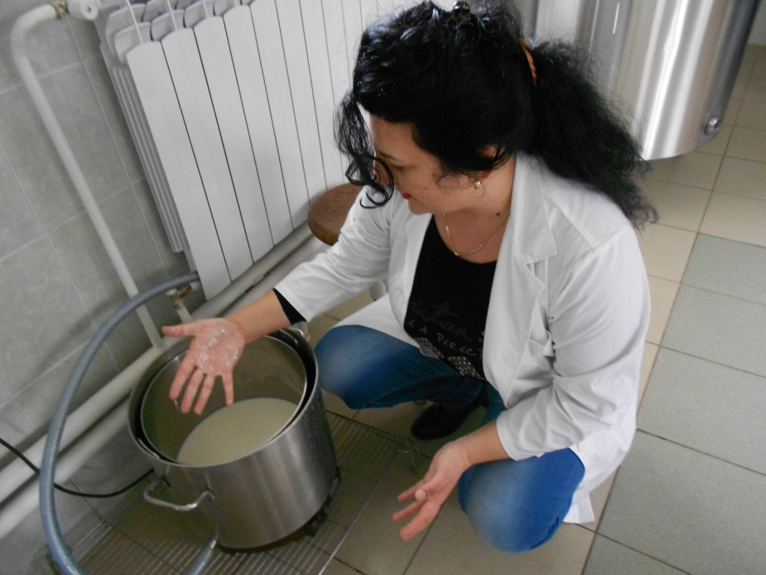
Figure. 1: A laboratory view for the Coagulation processes.

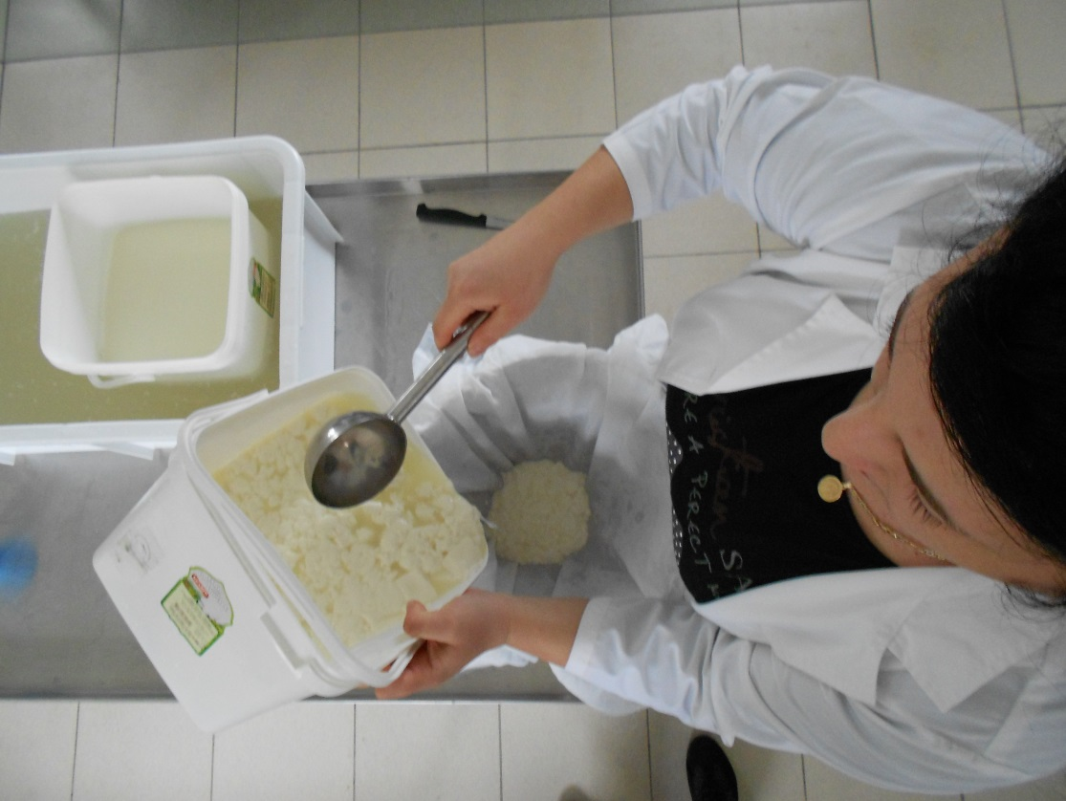
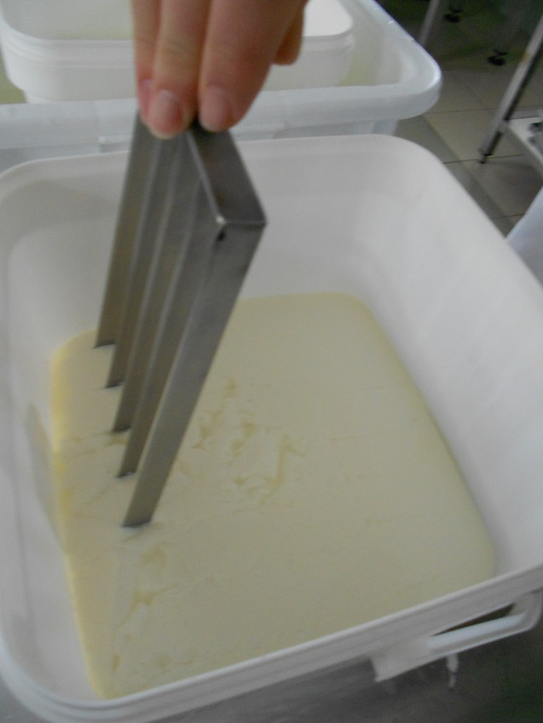

Figure. 3: Squeezing the way and measurement of its quantity in %.
Figure. 2: Cutting the coagulum with a cheese Harf.

We measured various parameters statistically from the samples and those values are depicted in Table 2. In the table the total 25 cows, distributed into 2 groups of cows, (i) Group – N Number of cows = 10 samples means cows with normal milk urea level and (ii) Group – H Number of cows = 15 samples (high milk urea level). Parameters of variation were ≥ 31.5% for each milk coagulation properties, whereas for the other chemical parameters, they were ≤ 31.5% (Table 2). Coagulation properties of milk were slightly damaged at milk with increased urea nitrogen level as observed in many authors (e.g. Ikonen et al. 1999a, Caroli A. et al. 1990) [20-21]. Testing of milk clotting ability, curd characteristics and separation of the soluble phase, give a good enough estimate of the milk coagulation ability of the individual samples of one dairy herds.

Table 2. Differences in DMY (daily milk yield), milk chemical components, and physical and technological properties between N cows with normal milk urea nitrogen level and H cows with high milk urea nitrogen level.
Various Parameters |  | Group - N  Number of cows = 10 |  | Group - H  Number of cows = 15
Abbreviation | Units | x ± sd | Range  (min-max) | x ± sd | Range  (min-max)
DMY | Lit/Day | 22.27 ± 3.33^{B} | 18.0 - 28.9 | 25.7 ± 5.46^{B} | 16.0 - 35.0
FAT | (%) | 3.77 ± 0.07 | 3.7 - 3.9 | 3.89 ± 0.32 | 3.4 - 4.8
LAC | (%) | 4.45 ± 0.15 | 4.3 - 4.7 | 4.40 ± 0.19 | 4.1 - 4.8
SNF | (%) | 8.33 ± 0.07 | 8.3 - 8.4 | 8.48 ± 0.15 | 8.2 - 8.8
PC | (%) | 3.18 ± 0.09 | 3.1 - 3.4 | 3.42 ± 0.22 | 2.8 - 3.7
MUN | (mol/L) | 6.22 ± 1.40^{A} | 3.1 - 7.9 | 10.22 ± 1.73^{A} | 7.4 - 12.5
SCC | (10³ * ml⁻¹) | 223.3 ± 8.15 | 210 - 230 | 225.0 ± 17.84 | 200 - 250
pH | --- | 6.66 ± 0.11 | 6.5 - 6.8 | 6.54 ± 0.06 | 6.6 - 6.8
SH° | 0.25 mol.L⁻¹ with NaOH | 8.26 ± 0.82 | 7.2 - 9.8 | 8.24 ± 1.25 | 5.8 - 10.3
RCT | (second) | 10.80 ± 1.87 | 8.0 - 13.0 | 10.80 ± 3.34 | 6.0 - 20.0
TCT | (second) | 2940.0 ± 296.6^{A} | 2580 - 3300 | 3496 ± 250.9^{A} | 3060 - 3900
W | (%) | 74.94 ± 5.16^{A} | 68.3 - 83.0 | 84.90 ± 7.99^{A} | 70.0 - 94.0
pH(W) | --- | 6.52 ± 0.08 | 6.4 - 6.6 | 6.60 ± 0.08 | 6.0 - 6.7
SH°(W) | 0.25 mol.L⁻¹ with NaOH | 5.98 ± 0.82 | 4.5 - 7.4 | 6.14 ± 0.97 | 4.8 - 8.6
Note:- Some abbreviations of the above table are such as:- Statistical significance of differences: ^{A} means:- differences between the average values in rows are statistically significant at p < 0.001 and ^{B} means:- differences between the average values in rows are statistically significant at p < 0.05,
x ± sd means arithmetic mean values of different parameters with standard deviation, DMY – daily milk yield, FAT – fat content, LAC – lactose, SNF – solids non fat, PC – protein content, SCC – somatic cell count, MUN – milk urea nitrogen, pH – acidity, ⁰SH– titratable acidity, RCT- rennet coagulation (gelation) time, TCT – total coagulation time, W – separated whey quantity, pH(W)- whey acidity; ⁰SH (W) – whey titratable acidity.

From Table 2, we can say, that the average values of daily milk yield (DMY) in H-cows were higher by 13.35% than N-cows and this high difference was significant (P< 0.001) also depicted in Figure 4 (a). The studied high daily milk yield (DMY) parameter had statistically significant influence (P < 0.05 and P < 0.001) on such milk indicators; FAT, lactose, solids non fat, MUN, TCT and separated quantity of whey. The differences of the content of FAT, LAC and SNF between the N and H groups have been seen in Figures 4 (b-d). From these figures one can conclude that in all these parameters there is existing difference in values between groups, especially the values are higher at group H, but there isn’t statistical significance between these parameters. Depending on the chemical composition of the milk in Pelagonia dairy farms, these parameters are in good correlations with the other workers [22-24]
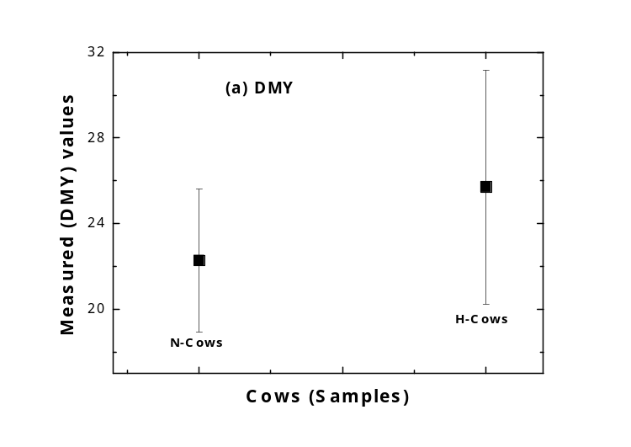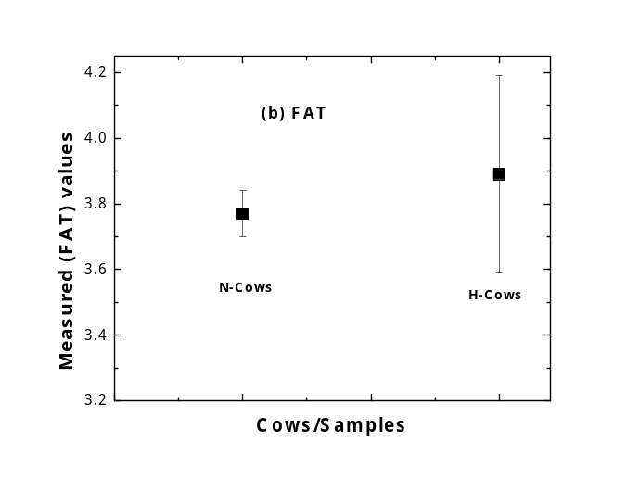
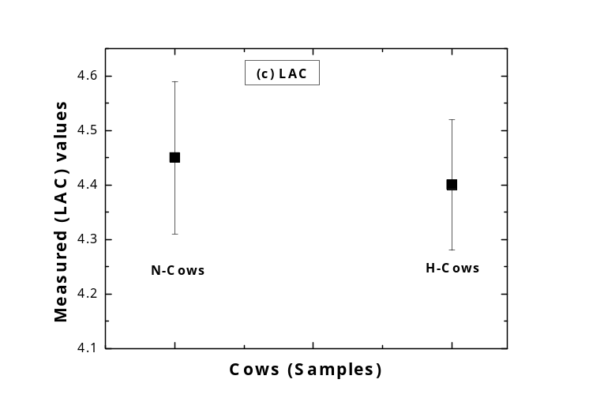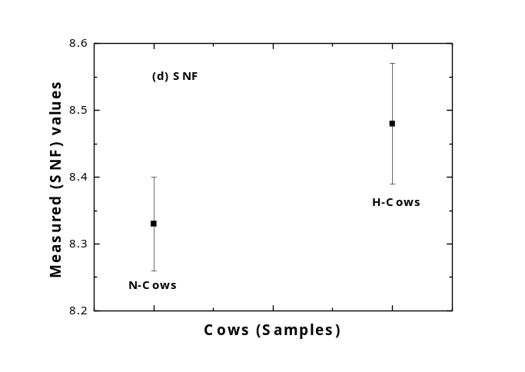

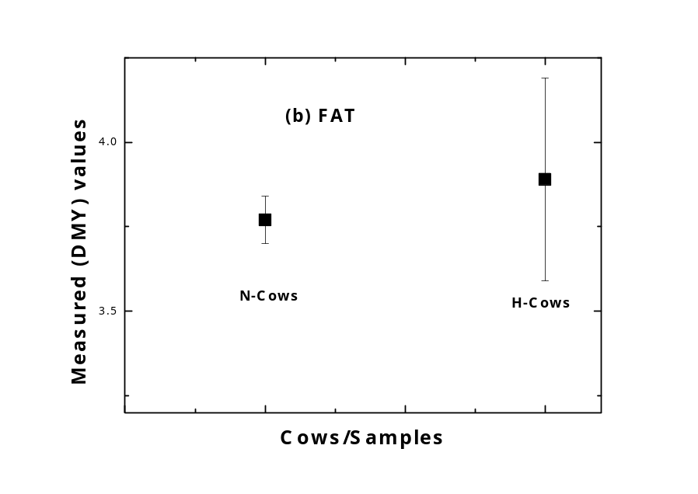
Figure 4 (a-d): For the statistically measured values of DMY, FAT, LAC and SNF for both groups of cows (sample).
The pH values were also measured for N-cows (10 samples) and found approximate 6.66 ± 0.11, and within the minimum and maximum range 6.5 - 6.8. Also the pH measured for H-cows (15 samples) and found approximate 6.54 ± 0.06, and within the minimum and maximum range 6.6 - 6.8. Therefore on behalf of measured pH values one can say that there is no fundamental effect on the milk coagulation properties in both groups of dairy cows. We have drawn the figures 5 (a-d) for the values of pH, °SH, pH(W) and °SH(W), from these figures one can see that these values are almost constant for N-cows and H-cows, although a slight difference between such values. Therefore behalf on these figures, we can say that, such parameters are in good correlations with the other workers [25-27] and the effect of these parameters pH, °SH, pH(W) and °SH(W), were of no practical relevance.

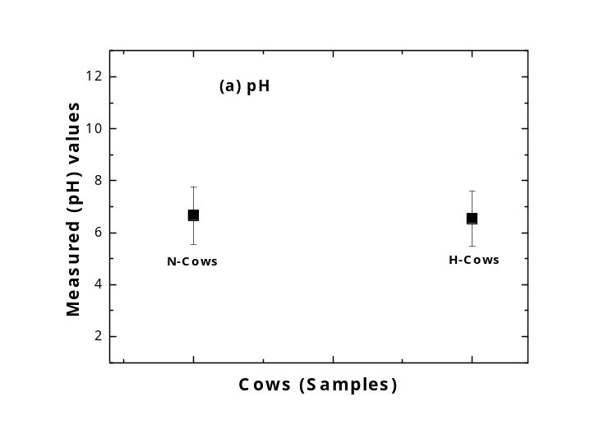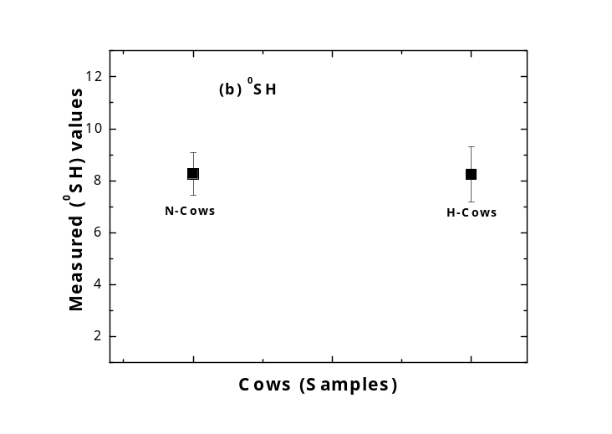
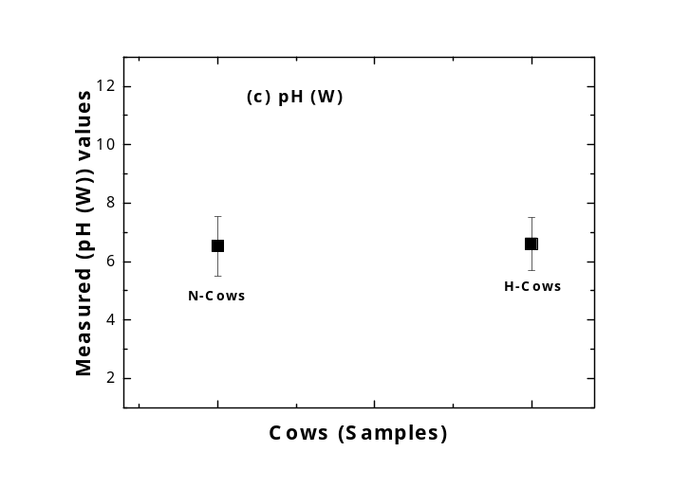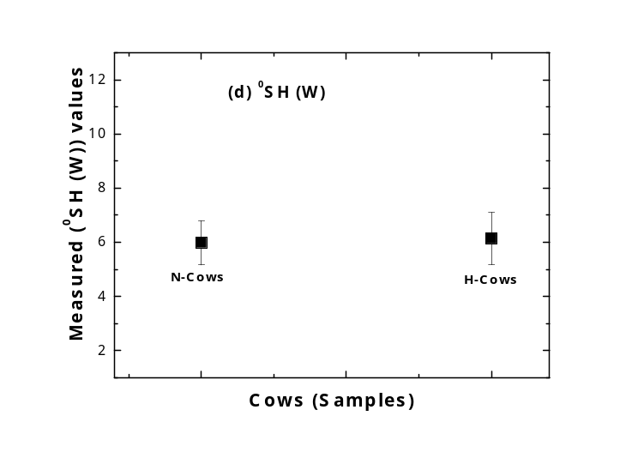

Figure 5 (a-d): For the statistically measured values of pH, °SH, pH (W) and °SH(W) for both groups of cows (sample).

The milk urea is an energy and nitrogen metabolism indicator [28], that is why milk urea nitrogen (MUN) was examined and it is also important for genetic [29] point of view. Its unsatisfactory (high, sometimes also low) values are often linked with aggravated reproductive performance [29, 30]. MUN was influenced significantly (P ≤ 0.05) by high daily milk yield (DMY) in the present research work. In figures 6 (a-d), we have drawn some results from the study of MUN, RCT, TCT and W (in %). Also we can say that the values of RCT in Figure 6 (b) are almost constant for both the cows / samples, whereas the values of MUN, in figure 6(a), TCT in figure 6 (c) and W (%) in figures 6 (d) are very much significant. So, from these figures one can see that the values of TCT and W (in %) are strongly correlated for both the groups of N-cows and H-cows, where the prolonged total coagulation time –TCT, and higher percent of separated whey can be observed in milk in the H - group of cows, as a result of the effect of high milk urea nitrogen content. The present results are consistent with the findings obtained by other workers [25-30].
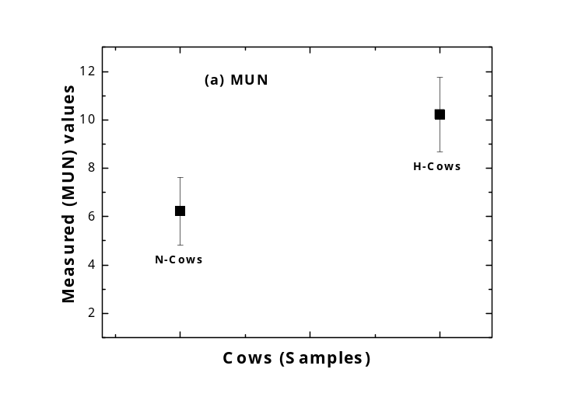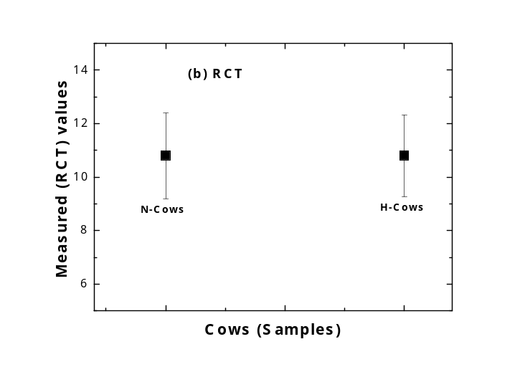
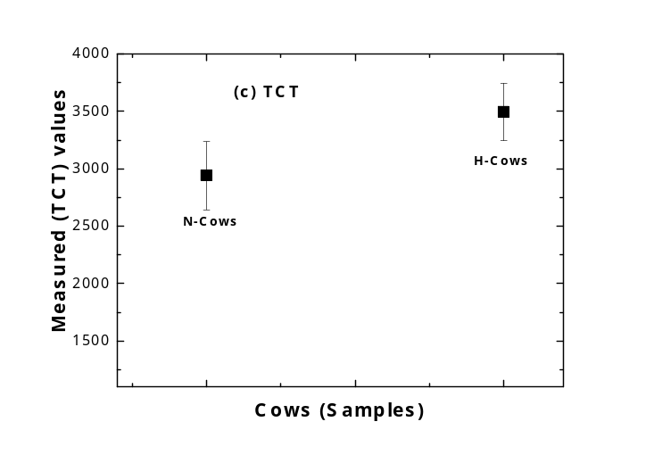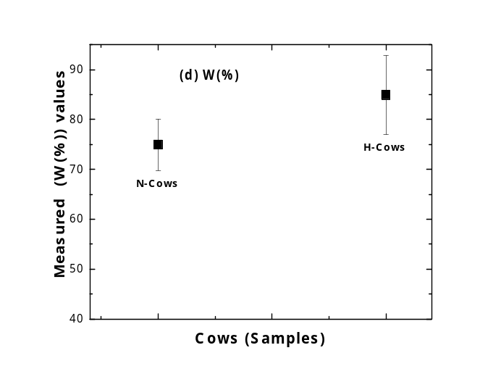

Figure 6 (a-d): For the statistically measured values of MUN, RCT, TCT and W (%) for both groups of cows (sample).

Conclusions and Final Remark
Based on our present statistical study, we can draw the following conclusions:
This study estimates for milk coagulation time and curd quality in this regard, we were of the same magnitude as those reported by Schaar (1984) [31], Caroli et al. (1990) [21] and Ikonen et al. (1997). This trial shows that nitrogen supply in the diet can influence cheesemaking. Milk urea is directly involved in milk clotting time, acidification kinetics and differences in curd quality. It has been realized significant differences between the groups of N-cows and H-cows, for various parameters, DMY, MUN, RCT, and TCT in the present cows samples have not caused the impaired technological milk quality. However, the technological quality was slightly better at cows with lower DMY. The high DMY reached by the genetic improvement of animals and their more efficient nutrition does not result in the noticeably impaired quality of raw milk. Nevertheless, there is reduced efficiency of milk processing in concentrated milk products a little. The results suggest that it would be interesting for the cheesemakers to determine the urea content of milk in some particular periods of the year in order to choose their cheesemaking parameters.
References
[1]. Summer A., Malacarne M., Martuzzi F., Mariani P. “Structural and fuctional
characteristics of Modenese cow milk in Parmigiano-Reggiano cheese production”,
Annali della Facoltà di Medicina Veterinaria, Università degli studi di Parma, 22, pp.
163–174, 2002.
[2]. Aleandri, R., J.C. Schneider and L.G. Buttazzoni, “Evaluation of milk for cheese
production based on milk characteristics and Formagraph measures”, J. Dairy Sci. 72,
pp.1967-1975, 1989.
[3]. De Marchi, M., G. Bittante, R. Dal Zotto, C. Dalvit and M. Cassandro, “Effect of
Holstein Friesian and Brown Swiss breeds on quality of milk and cheese”, J. Dairy Sci.
91, pp. 4092-4102, 2008.
[4]. Wedholm, A., L.B. Larsen, H. Lindmark-Månsson, A.H. Karlsson and A. Andrén,
“Effect of protein composition on the cheese-making properties of milk from individual
dairy cows”, J. Dairy Sci. 89, pp. 3296-3305, 2006.
[5]. O’Callaghan, D. J., C. P. O’Donnell and F.A. Payne, “On-line sensing techniques for
coagulum setting in renneted milks”, J. Food Eng. 43, pp. 155-165, 2000.
[6]. O’Callaghan, D.J. & Guinee, T.P. “Rheology and texture of cheese”. Cheese:
Chemistry, Physics and Microbiology, Vol. 1: General Aspects (Eds. P.F. Fox, P.L.H.
McSweeney, T.M. Cogan & T.P. Guinee), 3rd edn, pp. 511–540, 2004, Elsevier
Academic Press, Amsterdam.
[7]. De Marchi, M., C.C. Fagan, C.P. O’Donnell, A. Cecchinato, R. Dal Zotto, M. Cassandro,
M. Penasa & G. Bittante, “Prediction of coagulation properties, titratable acidity, and
pH of bovine milk using mid-infrared spectroscopy”, J. Dairy Sci. 92, pp. 423-432,
2009.
[8]. Schafer, H.W. & Olson, N.F. “Characteristics of Mozzarella cheese made by direct
acidification from ultra-high temperature processed milk”, Journal of Dairy Science, 58,
pp. 494–501, 1975.
[9]. Harwalkar, V.R.& Kalab, M. “Milk gel structure. XI: Electron microscopy of glucono-
lactone induced skim milk gels”, Journal of Texture Studies, 11, pp. 35–49, 1980.
[10]. Harwalkar, V.R. & Kalab, M. “Effect of acidulants and temperature on microstructure,
firmness and susceptibility to syneresis of skim milk gels”, Scanning Electron
Microscopy, III, pp. 503–513, 1981.
[11]. McMahon, D.J., Oberg, C.J. & McManus, W. “Functionality of Mozzarella cheese”,
Australian Journal of Dairy Technology, 48, pp. 99-104, 1993.
[12]. Guinee, T.P. & Fox, P.F. “Salt in cheese: physical, chemical and biological aspects”,
Cheese:Chemistry, Physics and Microbiology (Edn. P.F. Fox), Vol. 1, 2nd Edn,
pp. 257–302, 1993. Chapman and Hall, London.
[13]. Mariani P, Bonatti P, Sandri S., “Contenuto di urea, pH, aciditа totabile e caratteristiche
di coagulazione dei latte di singoli allevamenti. Ind Latte 28, pp. 3-17, 1992.
[14]. PECORARI M., MARIANI M.S., CALZOLARI M. G., TEDESCHI G. "Il contenuto di
urea nel latte: variazioni e rapporti con i parametri tecnologici" Sc. Tec. Latt. Cas., 44,
(3), pp. 144, 1993.
[15]. National Research Council recommendations (NRC, 2001).
explore.noaa.gov/sites/OER/.../national-research-council-voyage.pdf
[16]. M. Mele, R. Dal Zotto, M. Cassandro, G. Conte, A. Serra, A. Buccioni, G. Bittante, and
P. Secchiari, “Genetic parameters for conjugated linoleic acid, selected milk fatty acids,
and milk fatty acid unsaturation of Italian Holstein-Friesian cows”, J. Dairy Sci. 92, pp.
392–400, 2009.
[17]. The Dairy Practice Book, (2013),
http://web2.mendelu.cz/af_291_projekty2/vseo/stranka.php?kod=1164
[18]. Anna-Maria Tyriseva, Tiina Ikonen and Matti Ojala, “Repeatability estimates for milk
coagulation traits and non-coagulation of milk in Finnish Ayrshire cows”, J. of Dairy
Research, 70, pp. 91-98, 2003.
[19]. Pernille D. Frederiksen, M. Hammershoj, Mette Bakman et al., “Variations in
coagulation properties of cheese milk from the Danish dairy breeds as determined by a
new oscillation rheometry-based method”, Dairy Sci. & Technol. 91, pp. 309-321,
2011.
[20]. Ikonen T, Ahlfors K, Kempe R, Ojala M & Ruottinen O., “Genetic parameters for the
milk coagulation properties and prevalence of noncoagulating milk in Finnish dairy
cows”, Journal of Dairy Science 82, pp. 205–214, 1999a.
[21]. Caroli A, Bolla P, Pagnacco G, Rampilli M & Degano L., “Repeatability of milk
clotting aptitude evaluated by lactodynamographic analysis”, Journal of Dairy Research
57, pp. 141–142, 1990.
[22]. Tyriseva¨ A-M, Morri S, Ikonen T, Ruottinen O, Saarinen K & Ojala M., “Genetic
correlations between milk coagulation traits, casein content and milk production traits.
In Book of Abstracts (No 6) of the 51st, Annual Meeting of the European Association
for Animal Production, p. 86, 2000. Wageningen: Wageningen Perss.
[23]. Bezdicek J., Hanus O., Bjelka M. Dufek A., “Analyse of the relationship between milk
components and reproduction in the Czech Fleckvich first-calf cows”, Acta Univ.
Agric. Et Silvic. Mendel. Brun, LVII, (1), pp. 13-26, 2009.
[24]. Gustafsson A., Emanuelson U., “Milk acetone as indicator of hyperketonaemia in dairy
cows-the critical values revised”, Proc. EAAP Cong. pp. 443, 1993, Aarhus Denmark.
[25]. A guide to pH measurement, “the theory and practice of laboratory pH applications”,
2003, www.radiometer-analytical.com/pdf/ph_theory.pdf
[26]. D. Rehhak, R. Rajmon, M. Kubesova, J. Volek, F. Jlek, “Relationships between milk
urea and production and fertility traits in Holstein dairy herds in Czeh republic”, Czech
J. Anim. Sci. 54 (5), pp. 193-200, 2009.
[27]. Alba Sturaro et.al., “Study of milk coagulation properties in multibreed Italian dairy
herds”, 20th Int. Symp. “Animal Science Day”, Kranjska gora, Solvenia Sep. 19th -21st,
2012.
[28]. C. Cipolat-Gotet, A. Cecchinato, M. De Marchi, M. Penasa, and G. Bittante,
“Comparison between mechanical and near-infrared methods for assessing coagulation
properties of bovine milk”, J. Dairy Sci. 95, pp. 6806–6819, 2014.
[29]. Calamari, L., P. Bani, M. G. Maianti, and G. Bertoni., “New researches on the factors
affecting milk acidification rate. Sci. Tecn. Latt. Cas. 56, pp. 47–55, 2005.
[30]. Kamoun M., Jemmali B., Selmi H. Tayechi L., Badreddine M. And Dridi J.,
“Monitoring milk urea level and feed ration as a potential tool for milk quality”, Journal
of Phys & Pharm. Adv., 2(1), pp. 69-76, 2012.
[31]. Schaar J., “Effects of k-casein genetic variants and lactation number on the renneting
properties of individual milks. Journal of Dairy Research, 51, pp. 397–406, 1984.
[32]. Ikonen T, Ojala M & Syva¨oja E-L., “Effects of composite casein and blactoglobulin
genotypes on renneting properties and composition of bovine milk by assuming an
animal model”, Agricultural and Food Science in Finland 6, pp. 283–294, 1997.

Biographies

Vesna Karapetkovska Hristova completed the magistracy thesis in Quality and safety of animal products, in 2011 at the Faculty of Biotechnical Sciences, Bitola, Macedonia. Her PhD is in progress at the Faculty of Agronomy, Trakian University, Bulgaria. Since 2007 to the present, she is working as a Teaching Assistant at the Department of Farm production and veterinary sciences at the Faculty of Biotechnical Sciences, Macedonia.

Dr. M. Ayaz Ahmad completed Ph.D. in Experimental High Energy Physics in 2010 and M. Phil. (Physics) in 2005 from the Physics Department, Aligarh Muslim University, Aligarh, India. He is working as an Assistant Professor at Physics Department, University of Tabuk, Saudi Arabia. Recently, he is involved in multidisciplinary research along with his teaching responsibilities and he has published more than 40 research papers in various repute national and International journals. The citations of his research work are 119+ by various authors.



Dr. Julijana Tomovska, completed PhD at Natural Sciences and Mathematics - Institute of Chemistry in 2005, in Skopje, Republic of Macedonia. She works as a full professor in the field of Chemistry at the Faculty of Biotechnical Sciences @ Bitola, University, St. Kliment Ohridski,, Bitola. She is author and co-author in many papers, for now she has published 80 scientific papers in national and international journals, participated in many projects and is currently Dean of the Faculty of Biotechnical Sciences, Bitola.

Biljana Bogdanova Popov completed the magistracy thesis in filed Ecology and environment protection, in 2003 at South-western University ”Neofit Rilski”, Blagoevgrad, Bulgaria, in 2003. Since 2002 worked at the Faculty of Biotechnical sciences, Bitola and from 2009 she is working at Veterinary faculty, Bitola, Macedonia as a Teaching Assistant at Preclinical department in fields of interest, biochemistry, ecology.


