The Influence of Deposition Conditions on Properties of HgI₂
Ali M. MOUSA ¹ and JASIM SHAMKI ALIKHAN²
₁ Department of Applied Sciences, University of Technology, Baghdad, Iraq
₂ Department o physics , University of al-mustansiriya, Baghdad, Iraq
Abstract The effect of deposition conditions on the electrical and structural properties of deposited HgI₂ films were studied .The films were deposited from solution under dark and room light illumination condition. XRD ,An increase in the grain size was noticed. The electrical properties revealed a dependence on deposition conditions. Dark resistivity increases to1.084E+8 (Ω cm) when deposition was carried out in darkness while dark resistivity was 7.32 E+7 at light illumination.
,

1-introduction
Red mercuric iodide (HgI₂) is a wide band gap semiconductor material (E_{g}=2.13 eV) at 300K with high atomic number (80,53) Due to the low dark current, high stopping power for photon, higher number of charge pair caused by irradiation, higher absorption coefficient for x-ray and gamma-ray detection, It was considered to be of the most promising semiconductor material for room temperature nuclear[1-3] radiation detection and x-ray imaging[4]. It is difficult to grow large crystals of HgI₂ with good uniformity; as a result, they are not well suited for applications such as imaging devices which require large surfaces [5–8]. Using thin polycrystalline layer instead of single crystal wafer is an alternative approach to overcome this difficulty which takes advantage of intrinsic properties of mercuric iodide [9–12].Deposition of a layer of HgI₂olycrystalline from solution is a very comfortable and reliable technique [8–11]; the basic principle requires controlled precipitation on substrate in order to form a layer .Hence, the characterization of electrical and structural properties of such layers is of a great concern both for evaluating their ability to fulfill the requirements needed and for improving their preparation. In view of this situation we have investigated the structural and electrical properties dependence of the HgI₂ thin film prepared by solution method on the deposition conditions (including illumination, and darkness) in order to understand the transformation accompanying the growth process.

2-EXPERMENTAL
Substrate used for deposition HgI₂ is borosilicate glass slides with dimensions (1.5*1.5cm),which were first cleaned in distilled water in order to remove the impurities and residuals from their surfaces, followed by rinsing in chromatic acid(for two days), to introduce functional groups called nucleation and/or epitaxial centers, which formed the basis for layer films growth. Then the samples were washed repeatedly in deionized water, and finally put in ultrasonic agitation with distilled water for 15 min then dried. Deposition of the HgI₂ films The sample studied here were polycrystalline film HgI₂ layers by solvent evaporation. HgI₂ powder (0.3 gm) from (DEHANE radial deform) was dissolved in (50ml) of volatile solvent (acetone) at 25 c^{ﮦ}. The solutions placed inside a beaker with surface area of (5cm² ), After that we add an amount of ionized water to the solution equal to that of solvent (50ml), and after about 30 minutes a particles of HgI₂ began to be deposited at the bottom of the beaker ,and after (24 hours) the residual solution have been pulled (most of it is water) from the beaker and keep the sample for (1 hour) to become dry as shown in fig(1) .The deposition of HgI₂ happened because the density of acetone is less than that of water ,so the acetone atoms moved toward the surface of solution while the unsoluble HgI₂ atoms in water will be separate from the solution and deposited at the bottom of the beaker, with a very little amount of HgI₂ deposited on the wall of the beaker.
2-1 Structural measurements
The diffraction spectra of HgI₂ films were obtained by scanning (2Θ) in the range (20-60) The structural properties of the layers were investigated by using X ray diffraction system (Lab X-XRD-6000/Shimadzu) which has the following characteristics: source: radiation of CuKα and with wavelength 1,54 A◦, scanning speed (5 degree/min),. The interplanar spacing is calculated from diffraction Bragg equation:
nλ = 2d sin θ,
where n is a positive integer. d is the interplanar spacing. The average grain size is deduced from Scherer equation :G.Z = 0.9λ/B cos θ,
where λ is the wavelength of X-ray radiation, and B is the full width half max. (FWHM). θ is Bragg diffraction

2-2 Optical measurements
The optical transmission measurement was performed at room temperature between (400-700) nm using phenix-2000 UV-VIS spectrophotometer.

2-3 Electrical measurements
Electrical measurements were carried out by using the planar structure to measure the electrical Current-Voltage curves were measured with the use of a dc power supplied(0-200 V), and (0- 100mA), and the output current was measured by Keithly Electrometer type 602. The electrical resistivity (ρ) of the deposited films is determined
As ρ = R b d/ l
where l, b, and d are the length, width, and thickness
of the film respectively. Sample resistivity was measured
3- Results of Discussion
3-1 X-Ray Diffraction Analysis
From the X-ray diffrograms the planes orientations were determined. Besides, grain size ,number of layers (NL), and microstress (σs) of HgI₂ were calculated. Figures (A)– (B) shows the XRD of deposited samples prepared under different conditions. Figures( A)-(B) represent XRD pattern for samples prepared at dark and light .it is clear that strong peaks are observed at (2Ɵ=14.22,21.54,24.87,29.66,41.87) which corresponds with reflection planes (002), (101), (102) (103) and(200) respectively ,are small intensities are (2Ɵ=32.31,51.65,59.81) which corresponds with reflection planes(112,213,202). The presence of these reflections indicates that a high degree of crystallization with a preferred orientation perpendicular to the c-axis. XRD showed that the films have polycrystalline tetragonal. Comparisons between our results and those of the JCPDS are showed good agreement and recent researches(13,55,56).

Figures 2 (A(dark),B(light)) reveal x-ray of thick film HgI₂ samples deposited under dark and light conditions. By comparison figures 1( A (light), B(dark)), it is found that the sample prepared at dark has intensity of reflection peaks is higher than that prepared in light, that means the crystallization is better with dark deposition. On the other hand , there is a shifting of the XRD peaks due to the stresses.
the sample prepared under dark possessed particle size bigger than particle size of the light sample which leads to minimized the number of layers , the density of dislocations ,and the microstrain will be less and full width half maximum which lead to the best crystallization with dark.
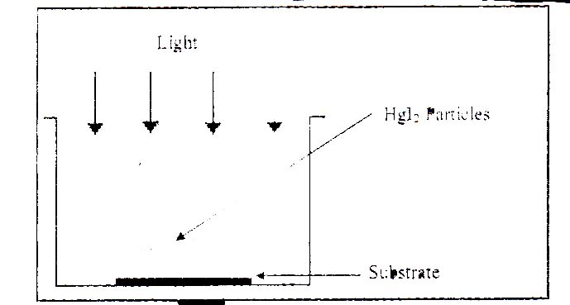
fig (1) show thick film deposition of HgI₂
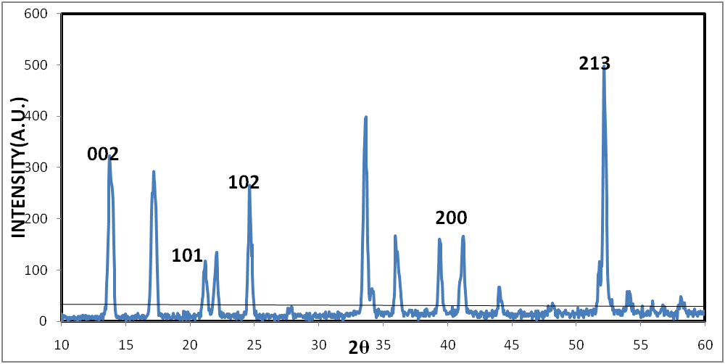
Fig (2-A) XRD patterns of HgI₂ films of light condition
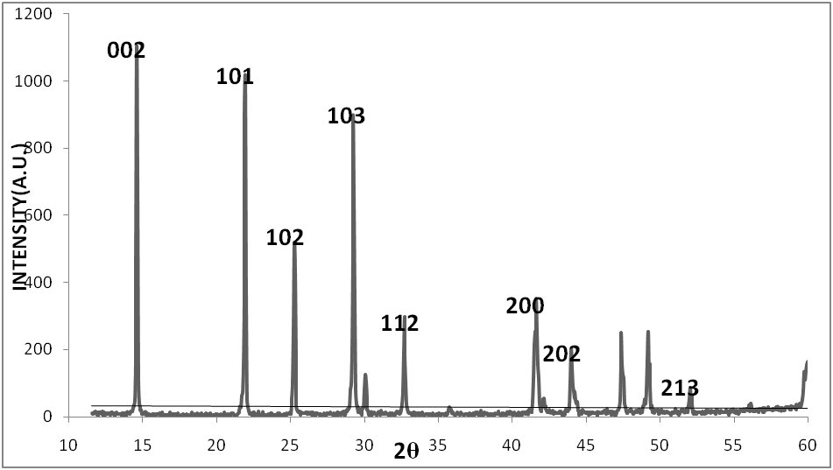Fig(2-B) XRD patterns of HgI₂ films of dark condition
The lattice constants (a) and (c)of the synthesized films are calculated[table 1] using the following relationships for tetragonal crystal structures: [13]
1/d² = h² + k² / a² + I² / (2.84a²)
the film prepared at dark it is found causes larger deviation at small angles(002).causing in turn increasing in parameter lattice (C◦ ,a◦).until larger angles(200) its corresponds to JCPDS . hence , we think that the samples are under(tensile stress) because its value is smaller than JCPDS .Except preferred orientation(103) under a( compression stress). because its value is larger than JCPDS.
The film deposited at light. was found causes larger deviation at small angles(002).causing in turn increasing in parameter lattice (C◦) (a◦).until larger angles(200) its corresponds to JCPDS ., hence , we think that the samples are under(compression stress) because its value is larger than that in JCPDS.
Table(1) lattice constants of thick film HgI₂ of different deposition
condition | hkl | d_{XRD} | d_{ASTM} | 2Ѳxrd | a_{XRD} | a_{ASTM} | c_{XRD} | c_{ASTM}
Dark | 002 | 6.031 | 6.223 | 14.67 | 4.237 | 4.369 | 12.062 | 12.440
Dark | 101 | 4.035 | 4.122 | 22 | 4.277 | 4.368 | 12.178 | 12.438
Dark | 103 | 3.047 | 3.009 | 29.28 | 4.427 | 4.371 | 12.60 |  | 12.44
Dark | 102 | 3.517 | 3.577 | 25.30 | 4.298 | 4.371 | 12.23 |  | 12.44
Dark | 200 | 2.172 | 2.186 | 41.53 | 4.34 | 4.37 | 12.35 |  | 12.44
light | 002 | 6.369 | 6.223 | 13.89 | 4.468 | 4.369 | 12.720 |  | 12.44
light | 101 | 4.186 | 4.122 | 21.20 | 4.430 | 4.367 | 12.613 |  | 12.438
light | 213 | 1.751 | 1.768 | 52.18 | 4.328 | 4.370 | 12.32 |  | 12.442
light | 102 | 3.605 | 3.577 | 24.67 | 4.405 | 4.371 | 12.542 |  | 12.445
light | 200 | 2.189 | 2.186 | 41.18 | 4.378 | 4.372 | 12.46 |  | 12.44

Table(2)shown the samples prepared at different conditions(dark, light).we have notice that the grain size of the plane(002) is bigger than other planes. so lowering value of the dislocation density at dark. While the plane(213) is bigger than other planes . so lowering value of dislocation density at light. There is a clear difference in the two values ​​in the two cases . at dark the value is very higher than the value at the light . at Light during the growth process leads to smaller grain size than in the dark, which indicates that the crystal formation might be influenced by the excitation of HgI₂ molecules. Our guess is that during light, high energy photons are absorbed by the HgI₂ molecules . Somehow , crystal nucleation and growth are enhanced when the molecules are not excited. According to our knowledge, this effect has never been studied for any semiconductor material except HgI₂,pbI₂[14].
Table 2 analysis of the XRD of thick HgI₂ film under different conditions
δ | N_{L} | ε | σ_{S} | G.S(n) | hkl | condition
6.31062E+14 | 291 | 0.000528 | 0.939 | 39.807 | 213 | light
2.89853E+15 | 623 | 0.004019 | 2.395 | 18.574 | 002 | light
2.80714E+15 | 614 | 0.002274 | 0.777 | 18.874 | 102 | light
1.11745E+14 | 209 | 0.00076 | 3.085 | 94.5 | 002 | dark
1.6435E+14 | 254 | 0.00047 | 1.263 | 78.0 | 103 | dark
3.81673E+13 | 122 | 0.00029 | 4.036 | 161 | 101 | dark

3-2 Optical properties
shows the spectral transmittances for film deposited at different conditions, In figure(2), sharp increasing starts around (≈550-580nm). show that the transmittances of film deposited in dark having lower transmission and this due to the bigger grain size, Optical band gap value was deduced from the extrapolated intercept of (α hv)² versus (hv). Absorption coefficient (α) was calculated from the transmission spectra using Beer-lamberts law [15]. α= 1/d lin1/T Where α: the absorption coefficient d: film thickness T: transmission of the film.

Fig(3) spectral transmittances for film HgI₂deposited at different conditions .

Fig(4) represent (αhν)² versus (hν)

Fig(5) represent (αhν)² versus (hν)
Electricity conductivity
The electrical conductivity was calculated from the measured electrical resistivity through the current – voltage characteristic. ( Figure7-8) shows ohmic behavior of samples. The dark current of both deposition(dark, light) increased linearly with applied voltage. These currents are influenced by different factors as such as material purity and by the deposition method[16]. the presence of defects and impurities in the starting material severely affect the device performance[17][18] it is concluded that the dark current is lower for the sample deposited in dark, while deposition under illumination gives higher dark current. The low current value for samples deposited under dark is probably due to the influence of grain boundaries. the grain size was found bigger under dark .hence the density of their grain boundaries is lower

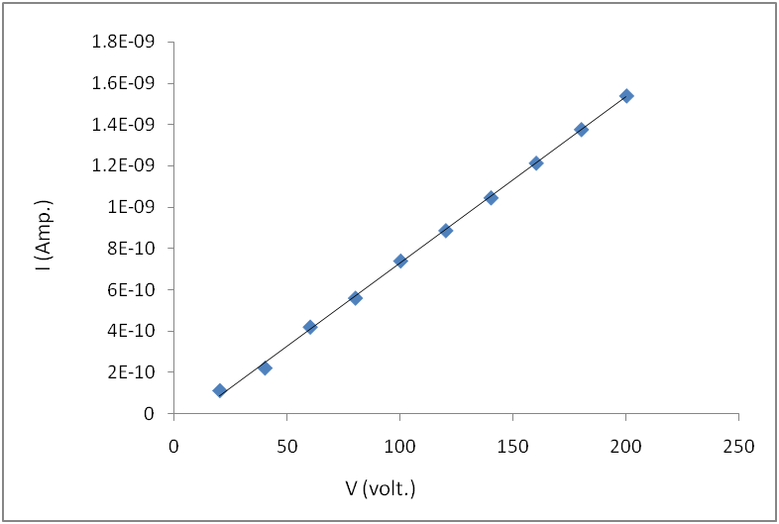
Figure (7): I-V characterization of HgI₂ thick film under light
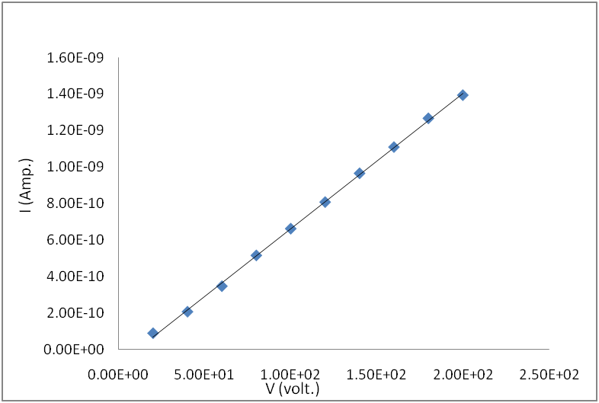
Figure (8): I-V characterization of HgI₂ thick film under dark
Table(3)the value of electrical properties of samples of thick film HgI₂
DARK CONDUCTIVITY(Ω.cm)⁻ | DARK RESISTIVITY(Ω. cm) | DEPOSITION
9.229E-9 | 1.084E+8 | DARK
2.323E-8 | 7.323E+7 | LIGHT

Conclusion
It has been shown that polycrystalline mercuric iodide layers with interesting properties can be prepared by means of a simple solution growth methods. All XRD patterns had the same peaks approximately. The grain size increases when deposition is carried out in darkness The illumination impact on the chemical reaction rates had strong consequences on the resulting layer characteristics..dark resistivity at darkness is higher than at illumination. dark current is less at dark than illumination.

REFRENCES

[1] R.Ahhuja,O.Eriksson, and Borje Johansson B,vol54,No15,(1996). [2]M.Schieber,H.Herwon,A.Zuck,A.Vi aensky,L.Melekhov,R.Shaturovsky,E. Mecrson,H.Ssaado,Preecedings of the SPIE medical imaging 2000 San Diego, vol.3977,p.48,(2000).
[3]E.R.Mancel,M.C.C.Custodic,F.E.G. Gumaraes,R.F.Bianchi,A.C. Hernandes,Materials Research
[4] A. I. Savchuk, V. I. Fediv, Ye. O. Kandyba, T. A. Savchuk, I. D.Stolyarchuk, and P. I. Nikitin, “Platelet-shaped nanoparticles of PbI₂ and PbMnI₂ embedded in polymer matrix,” MaterialsScience and Engineering C, vol. 19, no. 1-2, pp. 59–62, 2002.
[5] P.Montgomery, J. Ponpon,M. Sieskind, and C. Draman, “Surface
morphology analysis of HgI₂ and PbI₂ with interference microscopy: The challenges of measuring fragilematerials and deep surface roughness,” Physica Status Solidi C, vol. 3, pp.1044–1050, 2003.
[6] J. P. Ponpon and M. Amann, “Thermally stimulated current measurements on polycrystalline PbI₂ layers,” The European Physical Journal Applied Physics, vol. 18, no. 1, pp. 25–31, 2002.
[7] D. Bahvsar and K. Saraf, “Optical and structural properties of Zn-doped lead iodide thin films,” Materials Chemistry and Physics, vol. 78, no. 3, pp. 630–636, 2003.
[8] S. S. Novosad, I. S. Novosad, and I. M. Matviishin, “Luminescence and photosensitivity of PbI₂ crystals,” Inorganic Materials, vol. 38, no. 10, pp. 1058–1062, 2002.
[9] A. M. Mousa, “Optical and photoconduction in PbI2 polycrystalline deposited from solution,” International Journal of Modern Physics B, vol. 21, no. 21, pp. 3745–3753, 2007.
[10] J. P. Ponpon, A. M. Mousa, and M. Amann, “Compensation effect of Sn in PbI₂ polycrystalline layers,” Physica Status Solidi
A, vol. 205, no. 7, pp. 1653–1656, 2008.
[11] M. Yunus,Ph.D. thesis, College of Graduate Studies and Research, University of Saskatchewan, April 2005.
[12] J. P. Ponpon and M. Amann, “Preliminary characterization of PbI₂ polycrystalline layers deposited from solution for nuclear detector applications,” Thin Solid Films, vol. 394, no. 1-2, pp.277–283, 2001
[13]-J.S. BLAKEMORE,( “Solid State Physics”) , second edition CAMBRIDGE UNIVERSITY PRESS, 1989.
[14]-UgucioniI, J. C., FerreiraI, M., FajardoII, F., & Mulato, M. ("Growth of mercuric iodide crystals). Brazilian Journal of Physics,vol.36 no.2 . (2006).
[15]- Enck, M. A. ("Photoenhanced metastable deep trapping in amorphous chalcogenides near room temperature". Phys. Rev. B,vol 27 , p. 7402. ( 1983, June 15).
[16]- Mulato, J. C. ("Influence of deposition temperature, solvent, and solute concentration on the deposition mechanisms and final structure of mercury iodide fabricated using the spray pyrolysis technique"). J. Appl. Phys . (2006, May 20).
[17]- Skinner, N. L., Ortale, C., Schieber, M. M., & Vandenberg, L. Modified (purification of mercuric iodide for crystal growth.) J.CRYSTAL GROWTH,VO.L89, , P.86. (28 Sep. 1988).
[18]-A.tadjine, D.gosselin,J.M. koebel,and P.SIffert,(" search for correlation between electrical characteristics and stoichiometry in mercuric iodide,") nucl. Instum. Meth,vol.213,p.77,1983

